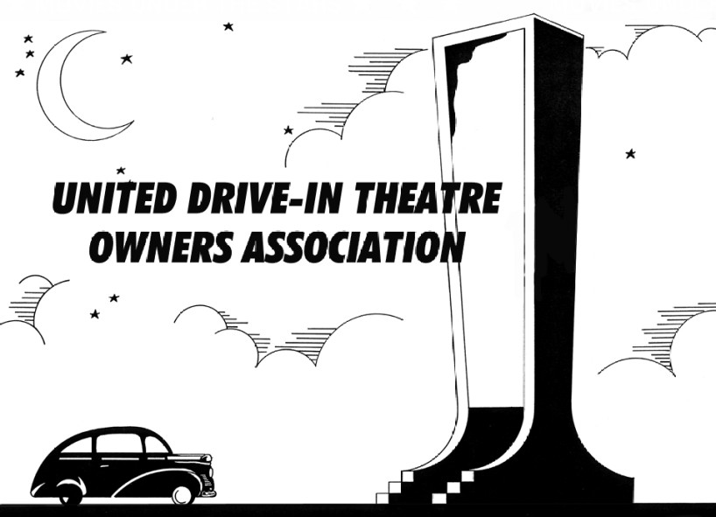

P.O. BOX 24771 Middle River, MD 21220-0771 Phone (443) 490-1250 http://www.uditoa.org

Dear Valued Member of the Theatre Industry:

You are invited to be a part of the United Drive-In Theatre Owners Association. The UDITOA was formed in 1999 as a not-for-profit business league of drive-in owners, lessee operators, and general managers.

The UDITOA's mission is:

To be the premier organization serving drive-in theatre owners;
To promote commercial motion picture exhibition at drive-in theatres world-wide; and
To ensure that drive-in theatres remain a viable and competitive part of the motion picture industry.

UDITOA is achieving this mission by forming a strong brotherhood of drive-in owners, operators and managers whom can help one another with problems, assist others in getting into the business, and educate the public, the media, and association members, and by striving to be a benchmark to the industry.

UDITOA publishes newsletters that you will receive. UDITOA's annual conference is held in early February. Past speakers include Jerry Selby, President Selby Products (screentowers); Brad Carroll, Manager of Exhibitor Relations Technicolor Services; John Evans, Vice President Gold Medal Products; Ric Forrell, Vice President and General Manager Universal City Walk; Chuck Viane, President Buena Vista Pictures Distribution, John Fithian, President National Association of Theatre Owners, Rory Bruer (President of Domestic Distribution) Sony Pictures, and many more. A small trade show was started in 2002 to allow vendors an opportunity to present their products.

Because you are an individual representing a business which services the motion picture industry, you qualify to become an Associate Corporate Member (non-voting). Associate members will receive the bi-monthly newsletter, the annual membership directory, and access to the UDITOA online discussion board.

Dues are $125 per year, payable with your application. Please fill out the information on the back of this form.

Associate Corporate Membership Application
Membership year is from October 1 to September 30.

Please fill out the following information and return with your dues of $125 and a business card. If your logo is on the business card, we can include it in the annual Membership Directory. If you prefer other artwork for your logo, please send that with the application.

The information below will be listed in the annual membership directory. Please print clearly.

COMPANY NAME:

NAME (individual applying for membership): MAILING ADDRESS: COMPANY WEBSITE: YOUR EMAIL ADDRESS: COMPANY PHONE:
YOUR CONTACT PHONE: FAX: OTHER PHONE:
Please check the category of service your company offers to the Drive-In Theatre Industry:

Beverage Booking Box Office ConcessionMarquee Pre-Show/Intermission Projection/Sound Screen AdsToys/Novelties Trailers
Other (explain):

Please specifically list your company’s main product(s) or service(s):

Signature: Date:

Return a copy of this form and annual dues payable by check or money order to:

United Drive-In Theatre Owners Association
P.O. Box 24771 Middle River, MD 21220-0771

